**Web Week 1 Lab**

**21F-9239**

**Abdullah Jabbar**

**1:**

<head>

    <Title>Abdullah's Webpage</Title>

</head>

<body>

    <b>Name:<tt>

        <blockquote><h2>Abdullah Jabbar</h2></blockquote>

        </tt></b>

    <p>

         <b>Roll Number:<tt>

            <blockquote><h2>21F-9239</h2>

            </tt></b></blockquote>

    </p>

    <p> <b>About:</b> <b><tt>

                <blockquote>

                    <h2>I am a Web Developer.</h2>

            </tt></b></p>

    </blockquote>

</body>

**Output:**

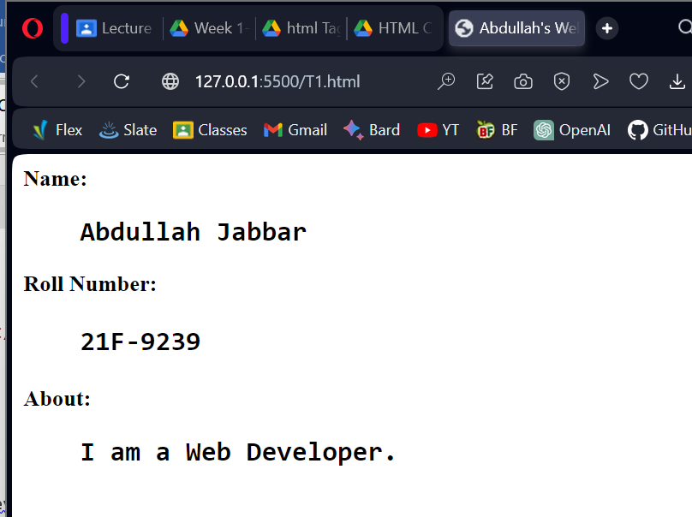

**2:**

<head>

    <title>Task 2</title>

</head>

<body>

    <B>

        <br>This text is bold</B><br><br>

    <strong>This text is strong</strong><br><br>

    <big>This text is Big</big><br><br>

    <cite>This text is italic</cite><br><br>

    <em>This text is Emphasized</em><br><br>

    <tt>This is Computer Output</tt><br><br>

    This is <sub> Subscript </sub> and <sup> Superscript</sup>

</body>

**Output:**

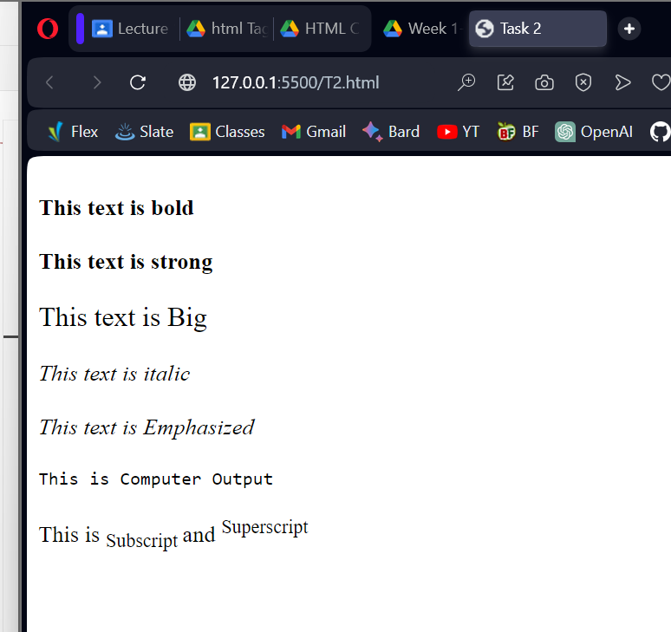

**3:**

<head>

    <Title>Abdullah's Webpage</Title>

</head>

<body>

<img src="Fast Logo.png" alt="Fast Logo" width="500" height="500">

</body>

**Output:**



**4:**

<head>

    <Title>Abdullah's Webpage</Title>

</head>

<body>

    <a href="https://cfd.nu.edu.pk"> <img src="Fast Logo.png" alt="Fast Logo" width="500" height="500"></a>

</body>

**Output:**

